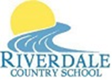

Riverdale Country School News

Volume XX; Issue 2 October 14, 2021

**American Rescue Plan BPS Community Meetings Scheduled – First One is Tonight!!**

**In This Issue:**

**\***

**\*”Right to Know”**

**Upcoming Events:**

**In This Issue:**

**\* Riverdale is a Title I School**

**\* Brevard Public Schools Codes of Student Conduct are Available Online**

**\* Right to Know**

**\* Report Cards and Student Assessments**

**Upcoming Events:**

**\* SPIRIT WEEK!**

**\* Trunk or Treat and**

**Halloween Parties!**

**October 31st.**

**\* NO SCHOOL on**

**November 11th**

**Veterans’ Day**

**November 27th – 29th**

**Thanksgiving Break**

The 2021 American Rescue Plan (ARP) is the federal government's latest COVID-19 stimulus package. It includes roughly $140 million for Brevard Public Schools. The school district is preparing a plan to best use this money and we want to hear from you. There will be four community meetings in the coming weeks designed to get input from people who live in Brevard.

The first meeting is tonight – the 14th in the Titusville High School Auditorium. The meeting will take place from 5:30 pm - 7:00 pm.

The other meetings will take place:

Cocoa High School – October 20, 5:30 – 7:00 Cocoa Beach Jr/Sr – November 4, 5:30- 7:00 Palm Bay Magnet High – November 9, 5:30-7:00 **Community members can also provide feedback and get information on the American Rescue Plan at https://sites.google.com/share.brevardschools.org/bpsesser/home**

**Riverdale Country School is**

**a Title 1 School**

Title 1 provides federal funding to schools that have high poverty levels. The funding is meant to help students who are at risk of falling behind academically. The funding provides supplemental instruction for students who are economically disadvantaged or at risk for failing to meet state standards. Riverdale uses Title 1 funds to purchase curricular and educationally relevant programs and technology to help our students increase academic achievement.

The 2021-2022 Title 1 documents are now available for your review. The Parent and Family Engagement Plan (PFEP) and the School Wide Improvement Plan (SWIP) are posted in the marquee in Riverdale’s front lobby. Printed copies of the PFEP and SWIP, the Comprehensive Needs Assessment (CNA) and the School-School-Family (S-F Compact) are in the Title 1 Parent Engagement Notebook located in the front office. These important Title 1 plans can also be found online on our website at [www.riverdalecountryschool.org](http://www.riverdalecountryschool.org). We invite you to read these Title 1 documents and provide your suggestions any time throughout the year. *Input from* ***ALL*** *parents, guardians, students, staff and community is vital to the success of our students!* You may request to have a copy of any of these documents at any time and upon request these documents can be translated for you using Google Translator – we apologize for any translation errors as they are unintentional. Estos documentos se pueden traducir a petición de Google Translator. Nos disculpamos de antemano por cualquier error en la traducción, ya que son involuntarios.

**Brevard Public Schools’ Code of Student Conduct Can Be Found at:**

 1. 1.[www.brevardschools.org](http://www.brevardschools.org) 2. Click on “Parents & Students” 3. You will see “Student Handbooks” under the “S” tab. Click on that and you will see “Code of Student Conduct “. The one handbook includes both the Elementary and Secondary Codes of Conduct.

**While you are at the Parent & Students tab look at all the other resources and information available to you!!**

1945 Palm Bay Road, Palm Bay, Florida 32905 Phone: (321)-728-2856; Fax: (321)-728-2623

Nik Torma, Director; Shannon Sullivan, Assistant Director

*“Try not to become a person of success, but rather try to become a person of value.” - Albert Einstein*

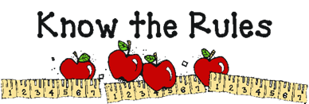

***Halloween Costumes***

Students may wear costumes on

Halloween – **BUT**:

**NO** Weapons, masks or

inappropriate clothing.

*“Each parent of a child at Riverdale Country School has a right to request the information about the professional qualifications of the student’s teachers and any paraprofessionals who serve the student. This information will be produced upon request.” This information remains available throughout the entire school year and upon request it can be translated for you.*

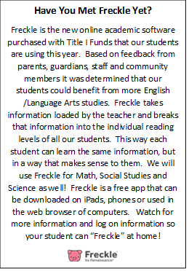

**Student AND School Report Cards – Remaining 2018-2019 Student Assessment Reports**

The 1st quarter report cards have arrived at Riverdale and will be mailed home Friday, October 25th. They will be mailed to all parents and guardians along with any student assessments still at the school at the address we have one file. As always, and throughout the school year Ms. Shannon can explain what the assessment scores mean. Please call or come by the school to set up a time to meeting with her, or go over it on the phone. Our number is 728-2856.

The Riverdale Country School, Florida Department of Education Report Card may be viewed on our website at <http://www.riverdalecountryschool.org> . As an Alternative Placement School we do not receive an actual grade, but there is a lot of information about our school for parents, guardians, staff and community members. This site will translate the report card and all its’ tabs into Spanish or Haitian Creole for your convenience. If you have any questions you may speak with Ms. Shannon or Mr. Nik.

SCHOOL IMPROVEMENT & SCHOOL ADVISORY COUNCIL

Help Us Improve Our School! Come be a part of Riverdale’s Improvement Committee!

Please join us **on November 15th and December 13th**

from 8:30 am - 9:00 am



***Stay Safe This Halloween!!***

**1. Wear reflective clothing**

**2. Watch when crossing streets**

**3. Have adults check your candy**

**4. Watch out for Stranger Danger**

**5. HAVE LOTS OF FUN!!!**

