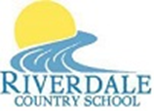

Riverdale Country School News

Volume XX; Issue 1 September 3, 2021

**And We’re Off…. to a New School Year!**

**In This Issue:**

**\***

**\*”Right to Know”**

**Upcoming Events:**

**Riverdale Country School is**

**a Title I School**

Title 1 provides federal funding to schools that have high poverty levels. The funding is meant to help students who are at risk of falling behind academically. The funding provides supplemental instruction for students who are economically disadvantaged or at risk for failing to meet state standards. Riverdale uses Title I funds to purchase curricular and educationally relevant programs and technology to help our students increase academic achievement at school and at home. ***Parents are a critical part of student success.*** *We want your participation in creating the 2021-2022 Title I Plans, including the School Improvement Plan, the Comprehensive Needs Assessment; the Parent Engagement Plan; and the Student-Family Compact for Learning!* ***You are invited to come collaborate on September 10th to discuss ideas on these plans!***

**Let’s *ALL* Get Together!**

We will have our first in-building Title I Stakeholder Event in well over a year! **On Friday, September 10, 2021 we will host an ongoing *2021-2022 Title I Plan Development Meeting for Stakeholders* from 8:30 am to 3:00 pm to discuss the development of Riverdale’s Title I Plans referred to in the column to the left.** We use the surveys parents, students, community members and staff graciously complete in addition to the information from this meeting.

**Good communication is key**!

We will also discuss the attached “A Guide to Parent - Teen Communication” – a flyer we received through Title I. Please review this flyer and think about the ways we can use Title I funds to help you work on academics with your student at home. ***Each year a percentage of our Title I budget is used for non-electronic items to help parents educate at home.*** FSA Scores will be available.

**Bring a family member or friend who is interested in helping develop these plans as a community member.**

**In This Issue:**

**\* Riverdale is a Title I**

**School**

**\* Title I Stakeholder Event**

**\* Mandatory Face Masks**

**\* Right to Know**

**\* FSA Scores Are Available**

**\* 2021-2022 Lunch and**

**Learn Webinar Series**

**\* Upcoming Events:**

**\* September 10, 2021 –**

**8:30 am – 3:00 pm Title I**

**Stakeholder Event**

**\* September 17th -8:30-9:00**

**am – School Improvement /**

**Advisory Council Meeting**

**\* Holidays – School Closed**

**\* Monday, September 6th,**

**Labor Day**

**\* Monday, October 11th,**

**District Inservice Day**



**It’s FACE MASK Time Again!**

Following the Emergency K-12 Face Covering Requirement from the Florida Circuit Court for the Second Circuit of Florida, and based on the CDC recommendation, Brevard Public Schools has implemented a mandatory face mask requirement for all (with a very few exceptions) students, employees, visitors, vendors or other person while indoors on school district property, including district transportation until September 29, 2021, minimally. **Please explain this to your students.** It is preferred that students have their own masks, but masks will be available on the bus and at Riverdale.

1945 Palm Bay Road, Palm Bay, Florida 32905 Phone: (321)-728-2856; Fax: (321)-728-2623

Nik Torma, Director; Shannon Boyd, Assistant Director, Rocio Dean, Education Coordinator

*“Try not to become a person of success, but rather try to become a person of value.” - Albert Einstein*



*“Each parent of a child at Riverdale Country School has a right to request the information about the professional qualifications of the student’s teachers and any paraprofessionals who serve the student. This information will be produced upon request and translated upon request.”*  ***ALL* Title 1 information remains available throughout the entire school year. You can request a copy at any time and upon request it can be translated for you using Google Translator. We apologize for any errors in translation. All plans are also on our website at**

[**www.riverdalecountryschool.org**](http://www.riverdalecountryschool.org)

**.**

**School will be closed this coming Monday, September 6th for Labor Day.**

Riverdale follows the Brevard Public Schools District Calendar. It is part of our registration packet and a copy can be sent home upon request. It is also available on our website at [**www.riverdalecountryschool.org**](http://www.riverdalecountryschool.org)**.**

FSA Test Scores Are Available!

Scores are available for pick up September 3rd – 10th. **You may also pick them up at the Title I Stakeholder Meeting on September 10th**. Any remaining scores will be sent home on the bus that afternoon. An information sheet explaining what the scores mean will be attached to the test scores. **You may request a meeting with Ms. Shannon to discuss your student’s specific scores.**

Please call 728-2856 to make an appointment.



SCHOOL IMPROVEMENT & SCHOOL ADVISORY COUNCIL

Help Us Improve Our School! Come be a part of Riverdale’s Improvement Committee! The 3rd Friday of the month from 8:30 am - 9:00 am

Please RSVP – 728-2856

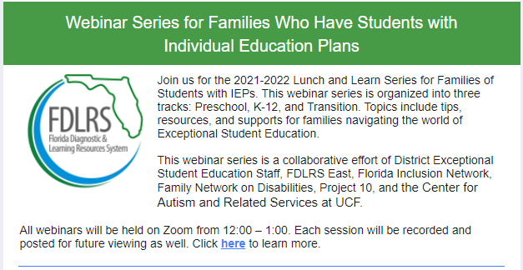

**To see upcoming dates/topics and to sign up go to:** <https://urldefense.com/v3/__https://www.fdlrseast.org/parent-services/2021-2022-parent-webinar-series__;!!OPumOOY!bKD3puZkT0weGaI2xM0bnEgeU6tfOX34PeE2IFOO6_PViMTML_NVL9jU06efWMbX$>

This link will be available on our website at [**www.riverdalecountryschool.org**](http://www.riverdalecountryschool.org)